# Table of contents

Insert Table of content here

# Open Letter

***From:*** TDTU

***To:*** Insert title and first name here

***Address:*** Insert address block here

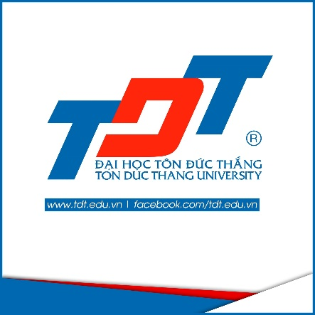**ABOUT TDTU**

* About TDTU
* Mission
* Long-term goals
* Contact
* Reference

# About TDTU

TDTU is a public university operated under the Vietnam General Confederation of Labor. Established on September 24, 1997, TDTU has developed into one of the TOP 2 universities in Vietnam. It is on the way to joining the ranks of the most prestigious Asia Pacific Higher Education institutions.

All the lecturers, administrative staff and students of TDTU strictly follow the three principles of operation:

NOthing is more important than being effective.

NOthing is more valuable than treating others fairly.

NOthing is more honorable than serving our country.

# Mission

TDTU has the responsibility of offering high quality human resources for Ho Chi Minh city (HCMC) and the whole country in which TDTU lays an emphasis on. Giving training to labor workers, conducting increasingly effective applied and scientific research to contribute to the country’s development in the long run and (iii) committing themselves to increase the country’s prosperity, stability and sustainability.

# Long-term goals

TDTU is determined to become an applied research university within the next three decades in parallel:

* Playing a role in training, retraining, fostering and promoting professional knowledge and required skills for the demands of the high quality human resources of the industrialized and modernized process of HCMC and other Southern provinces.
* Participating in the Program of building a functional labor force.

To achieve this goal, TDTU is pursuing the following official policies:

* KEep recruiting and training the academic forces carefully, building a team of highly qualified, professional and responsible staff and lecturers.
* ENhance the scientific research, applied research, training management and ISO working routines in all areas, commited to ensure the objective tests to standardize all university graduation requirements.
* Increase long-term and continuous investment in facilities for the next three decades. Ensure the adequate, intensive and timely facilities to accomplish quality objectives in each stage of training and researching.
* Lay an emphasis on both local and international media attention for the University.
* kEEP expanding the cooperation programs with international universities to enhance the University’s reputation, to facilitate more opportunities in learning and experience modern management, to benefit from the advanced knowledge of foreign countries, to receive the transfer of foreign training models; quickly improve the training quality of some majors equivalent to regional and international standards.
* All of the TDTU’s degrees are approved and accredited by international organizations.

# References

You has to insertbibliography here.

I wanted to let you no that there are many error in this sentene.